Stars, Galaxies, and the Universe Study Guide
______ 1. A light-year is
a. 365 days.
b. the distance light travels in a year.
c. the distance from Earth to Proxima Centauri.
d. the amount of light the sun produces in a year.

______ 2. What is a giant ball of hot gases that undergo nuclear fusion?
a. a planet
b. a star.
c. a star cluster
d. a solar system

______ 3. A range of colors formed when white light passes through a prism is called a
a. lens.
b. photograph.
c. spectrum.
d. ray.

______ 4. Characteristics used to classify stars include
a. distance, size, and color.
b. size, distance, and brightness.
c. color, brightness, and distance.
d. size, brightness, and temperature.
______ 5. The Hertzsprung-Russell diagram shows that main-sequence stars
a. are mostly hot and dim.
b. are mostly cool and bright.
c. increase in brightness as they increase in temperature.
d. decrease in brightness as they increase in temperature.
______ 6. Which of the following is a major difference between elliptical galaxies and spiral galaxies?
a. Elliptical galaxies have almost no gas or dust between the stars.
b. Elliptical galaxies vary more in shape than spiral galaxies.
c. Spiral galaxies have almost no gas or dust between the stars.
d. Spiral galaxies contain only old stars.
______ 7. One indication that a planet may exist near a distant star is that
a. the star varies in temperature.
b. the star has a very slight back and forth motion.
c. the star has very strong gravity.
d. radio wave activity increases near the star.
______ 8. According to Hubble’s law, the farther away a galaxy is,
a. the faster it is moving toward us.
b. the slower it is moving toward us.
c. the slower it is moving away from us.
d. the faster it is moving away from us.
Stars, Galaxies, and the Universe (continued)

Completion
Fill in the line to complete each statement.
9. The type of light humans can see is called ____________________ light.
10. Telescopes work by collecting and focusing different forms of ____________________ radiation.
11. An object’s apparent change in position when viewed from two different places is called ____________________.
12. ____________________ uses powers of ten to write very large or small numbers in shorter form.
13. According to the big bang theory, the universe formed about _________________________ years ago.
True or False
If the statement is true, write true. If it is false, change the underlined word or words to make the statement true.
____________ 14. Radio waves have shorter wavelengths than waves of visible light.
____________ 15. Astronomers typically measure distances to stars in units called kilometers.
____________ 16. A star system has at least three stars.
Essay
17. Compare and contrast a reflecting telescope and a refracting telescope.

18. Define parallax and explain how astronomers use it to measure distances to stars.

19. Explain the difference between the apparent brightness and absolute brightness of stars.
Stars, Galaxies, and the Universe (continued)
Using Science Skills
Use the figure below to answer the following questions in the spaces provided.
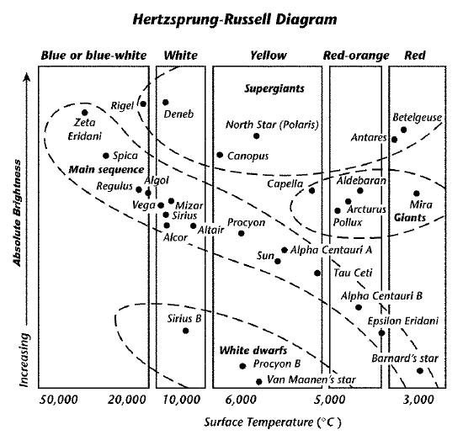
20. Using the figure, name the star that is very dim and red in color.

21. State how Barnard’s star and Mira are similar.

